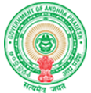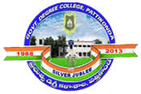**Government Degree College**

**ACCREDITED BY NAAC WITH ‘B’ GRADE** **Pattikonda,Kurnool (Dt),A.P.518380.**

**Dr R.Madhuri**

**Principal**

**2.5.1 - Mechanism of internal assessment is transparent and robust in terms of frequency and mode. Write description within 200 words.**

**Government Degree College, Pattikonda, Kurnool Dt., is an affiliated college of Rayalaseema University, Kurnool, and is guided by the rules and regulations formulated at the university level. The Academic calendar of Rayalaseema University, Kurnool is available on University and College websites. University follows grading system and in accordance with CBCS pattern. Grace grafting system is considered at the end of course as Bala Mohandas committee suggested. Students who are admitted are well informed about the assessment, question paper patterns, grading system and university examination system by conducting an orientation program for the students at the very beginning of the program. For transparent and robust mechanism in the internal examinations an Examination Cell is constituted in the college under the guidance of the principal. The examination coordinator assists the Principal during the conduct of both internal and semester-end examinations. The time table of Mid-term/ Practical Examinations will be communicated to the students by the coordinator at least one week in advance. The internal examinations schedule is prepared in accordance with completion of syllabus and preparedness of student. Students who failed to attend the internal exam were provided an opportunity to write examination after due recommendation from the HOD/Principal.**

